AKGEC/IAP/FM/02
Ajay Kumar Garg Engineering College, Ghaziabad
Department of ECE
Sessional Test-2

Course: B.Tech Semester: 5th
Session: 2017-18 Section: EC-1,2,3, EI-1
Subject: Integrated Circuits Sub. Code: NEC-501R
Max Marks: 50 Time: 2 hour

Note : Answer all the sections.

Section-A

- Attempt all the parts. (5x2 =10)

- How the quality factor changes the frequency response of the filter?
- Write down the performance parameters of a digital logic family.
- Give CMOS implementation of F= A̅B + AB̅ .
- What are the limitations of an ideal differentiator and ideal integrator circuit?
- Sketch properly labeled Master Slave D flip-flop circuit.

Section-B

- Attempt all the parts. (5x5 = 25)

- Design a wide band pass filter with f₁=100 Hz and f₂= 2 kHz and a passband Gain= 4. Also calculate the value of quality factor for it.

- Derive the output voltage equation for both floating and grounded load V to I converter using relevant diagram. Also mention applications of V-I converter.

- Give truth table and CMOS realization for half adder with input A & B.

- Draw the properly labeled VTC curve for the CMOS inverter. Describe each region and define the terms V_{IH} , V_{IL}, V_{OH} and V_{OL.}

- Draw GIC circuit and obtain expression for its equivalent input impedance. How we can simulate inductor with the help of a GIC circuit?

P.T.O.

Section-C

- Attempt all the parts. (2x7.5 = 15)

11. Design a second order low pass filter with cut off frequency 4 kHz. Also obtain frequency response curve for it.
For the circuit diagram given below find out the value of Vo and Io.

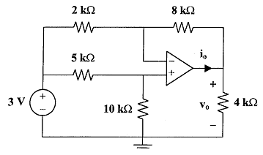

12. Why CMOS has less power dissipation. Draw CMOS implementation of Clocked SR flip flop circuit and explain its working operation.

